**PART A**

**A1**

### With the Supreme Court banning the sale of BS-III vehicles in India from April 1, 2017, auto manufacturers have updated their vehicles to comply with BS-IV emission norms. But what really is the difference between the BS-III and BS-IV emission norms? And how different will the motorcycles be?

**BS-IV isn’t new, is it?**

Right, the BS-IV emission standards were implemented in NCR and 13 cities including Mumbai, Kolkata, Chennai, Bengaluru, Hyderabad, Ahmedabad, Pune, Surat, Kanpur, Lucknow, Solapur, Jamshedpur and Agra from April 1, 2010. Nationwide implementation is from April 1, 2017.

**how exactly is BSIV different?**

BS-IV is the fourth stage of the emission standard incorporated by the government to regulate the amount of pollutants emitted by vehicles. There are various parameters on which the BS-III can be differentiated from the BS-IV.

The BS-IV emission values for two-wheelers are classified into five classes depending upon the engine capacities and maximum vehicle speeds. The classification of vehicles according to classes is common for both the BS-III and BS-IV emission standards. For motorcycles, the change slashes the emissions by 25 per cent for CO and 40-50 per cent for HC+NOx.

BS-IV is fighting a war on carbon monoxide (CO), hydrocarbons (HC) and other nitrous oxides (NOx). For diesel vehicles, the change slashes the emissions by more than half (almost 60 per cent) for the CO and 50 per cent for the HC and NOx. For petrol vehicles, the change slashes the emissions by 20 per cent for CO and 50 per cent for HC and NOx.

**Just how bad can a few grams here and there be?**

When you have millions of vehicles being added to the roads every year, it all adds up. Carbon monoxide is a highly toxic, colourless and odourless air pollutant. Carbon monoxide poisoning symptoms include headache, nausea, vomiting, dizziness, fatigue and weakness. It causes neurological dysfunction which may lead to confusion, disorientation, visual disturbance fainting and seizures. In severe cases, it may also cause coma.

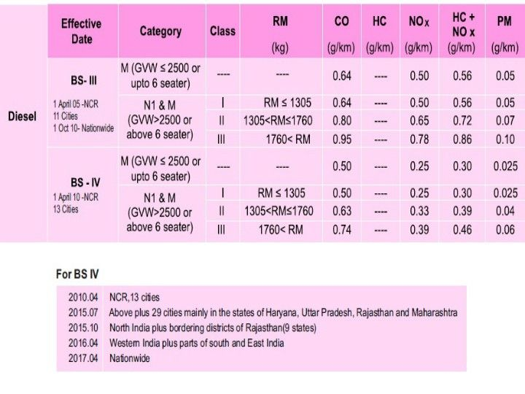

Inhaling hydrocarbons isn’t any nicer. Necrosis, abscess formation, respiratory system failure, damage to the kidneys, brain and nervous system are some effects. Nitrogen oxides react with volatile organic compounds in the presence of sunlight which destroys ozone. This results in damage to lung issues which lead to a reduction in lung functionality.

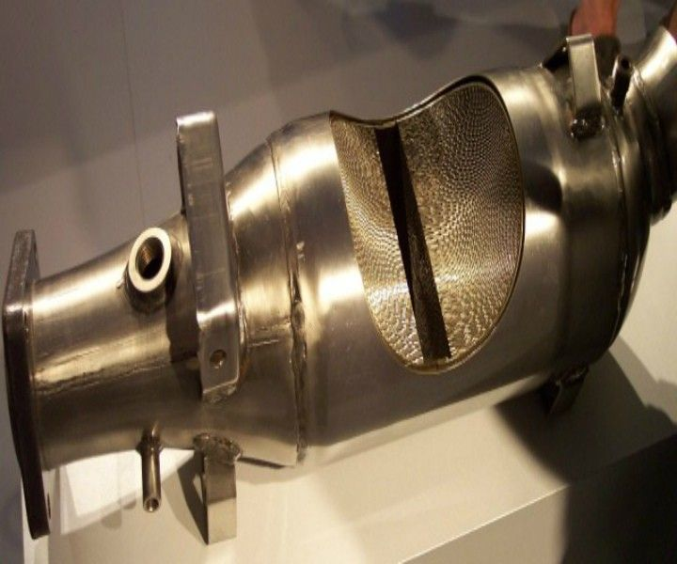

**Man! So manufacturers have fixed things I hope?**

All the manufacturers have updated their vehicles with BS-IV engines. Some motorcycle manufacturers have retuned the carburettor settings by adding more number of maps to the system. Fuel injection system has been incorporated to make them BS-IV compliant. Larger diameter muffler along with bigger catalytic converter helps in reducing the emissions. Vehicles feature Evaporative Emission Control System (EVAP) which recycle fuel evaporated from the tank and uses it for combustion. The use of fresh air injection into the exhaust port to burn any unburnt fuel has also helped improve tailpipe emissions.

**Can you retrofit these systems to existing vehicles?**

Existing motorcycles don’t need to get anything done as long as they have been bought before April 1, 2017. All new cars will have the updates.

**Lot of chaos currently?**

From the 1st of April no BS-III compliant vehicle will be allowed to be sold in India as per the orders of Supreme Court. As per SIAM, around 9 lakh BS-III vehicles with an estimated value of 12,000 crores are lying at the dealerships across the country. These vehicles won’t be registered by the RTO after April 1, 2017, which ideally means, they stand useless. Or as manufacturers have done, offered heavy discounts to get them off the dealership floors.

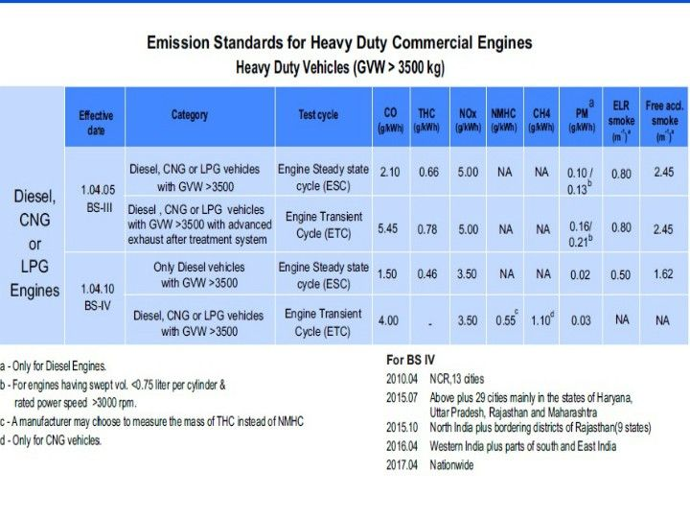

You can be sure that manufacturers are already hard at work to meet the BS-VI norms which come into effect April 2020.

The government of India had incorporated the Bharat Stage emission standards in 2000 to keep a check over the emission of environment depleting gases emitted by vehicles which are majorly responsible for global warming due to greenhouse effect. Over the course of years since 2000, the rules for emissions have become more stringent and today’s vehicles are running much cleaner compared to those in 2000.

**Number of tests –**

**BS-IV tests –**

Type 1 test is done to check the exhaust emission at Indian Driving Conditions (IDC). Indian Drive Condition is simulated on a test vehicle in a laboratory test called as constant volume sampling (CVS) system. The vehicle is mounted on rollers and anchored where the vehicle is driven as per the various resistances corresponding to the driving cycle are imposed. The system is tuned as per the data taken from actual urban and the actual driving cycle of the country. Type 2 test involves Spark Ignition testing which is carried out at idling condition to check the Carbon monoxide and hydrocarbons emission percentage. Type 3 test checks durability of anti-pollution devices determined by actual durability run which is carried over a distance of 30,000km or by application of a deteriorating factor.

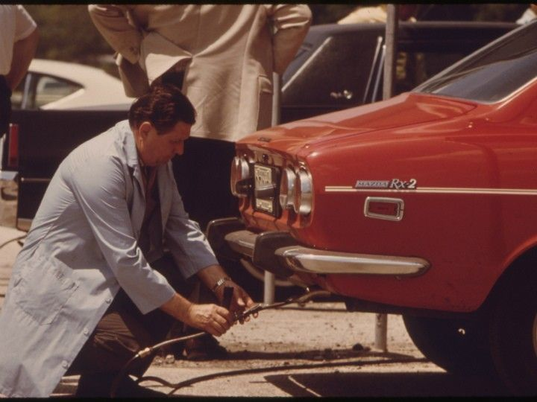

Type 4 and type 5 tests are carried for the determination of evaporative emissions and durability of anti-polluting devices. The primary focus of these tests is to control and regulate the CO and HC percentages. The evaporative emission tests are performed in two types – the 2g and 6g test. 6g type in the evaporative test reduces the HC+NOx emission by 15-20 per cent over the 2g test.

**Why is it important?**

We all are aware of the fact of depleting ozone layer due to the use of fossil fuel vehicles have incurred. The depletion of ozone layer has caused global warming which in turn is dangerous for the future survival of mankind.  It’s not that vehicles running on fossil fuels are solely responsible for the emission of harmful gases which have resulted in depletion of ozone layer; industries are also a part of it, but vehicles do play a big role.



Global awareness against the rising temperature has been created in the recent past and countries have started taking action to reduce pollution from vehicles and industries by limiting the percentage of harmful gases they produce. Emission norms were incorporated to keep a check and promote cleaner running vehicles in the times to come.

**A2**

# **From BSIII to BSIV**

## The transition of cars shifting from BSIII to BSIV has spun the Indian automotive industry in a panic! While this move benefits the environment, many automotive companies and dealerships have taken a hit. We list down what exactly is the theory behind the BS emission norm and how does it affect a consumer

**What does this do to current vehicle owners?**

The Supreme Court has banned the sale or registration of BSIII vehicles on or after 1st of April, 2017. This rule does not currently state if a BSIII vehicle cannot ply on the road. This means even if there is a vehicle compliant with BSIII emissions norms can be used on public roads without any legal implications. The problem would be more from a moral aspect as a BSIII compliant vehicle would pollute more than BSIV.

**What it means for used vehicle owners?**

Any used vehicle that will now be purchased will take sometime to be re-registered. Although, the detail by the apex court wasn't clear, but according to the ruling, it is expected that used vehicles not compliant with BSIV emission norms would not be registered. This would result is waste of money for a second-hand vehicle buyer.

**What if you buy a new vehicle with the discount on BSIII rated ones?**

A number of dealerships are offering discounts on BSIII compliant vehicles in order to clear their existing stock. This does result in a loss at the outlets' end, but it is not major and the dealer would not have to deal with recycling or scrapping of BSIII vehicle. What one needs to ensure is that the sale, loan and other necessary documents offered by the dealership are dated on or before 31st March, 2017 midnight. Any BSIII vehicle that is purchased after this time will not be registered according to the Supreme Court's ruling. So, in case one is planning to buy a BSIII complaint vehicle in the need of an added discount, confirm from the dealership that you would get your registration and other necessary documentation.

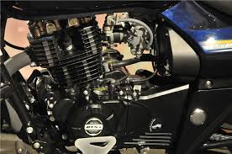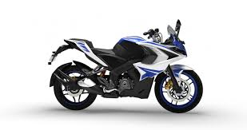

**A3**

In a move that should help citizens breathe better, the Supreme Court has banned the sale and registration of Bharat Stage III (BS-III) vehicles from April 1 when BS-IV emission norms come into effect across the country. The apex court cited public health as justification for its decision, even as automobile manufacturers asked for time to dispose of their existing stocks of BS-III vehicles. But BS-IV commercial vehicles such as trucks are 80% cleaner than the BS-III variants, while in two-wheelers the transition will see a reduction of 41-80% in polluting emissions. Hence, SC is on point in observing that continued sale of BS-III vehicles could aggravate the already deteriorating air quality in the country.

While some automakers were betting on April 1, 2017 to be the deadline for the commencement of production of BS IV compliant vehicles and not the sale of such vehicles, the Supreme Court ruling has come not a day too soon. India is on the radar of global automakers as vehicle penetration is still low here, compared to developed countries. Besides, many Indian cities are already among those with the poorest air quality in the world. Upgrading to stricter fuel standards helps tackle air pollution.

Other developing countries such as China have already upgraded to the equivalent of Euro V emission norms a while ago. So, India is lagging behind even after implementation of BS IV norms. Perhaps to compensate for this, BS V standards will be skipped and BS VI norms are proposed to come in by April 2020. Both vehicle manufacturers and fuel suppliers are already working to abide by this deadline.

**B1.1**

**Factors responsible for corrosion are:-**

**Primary factors**:-The nature of material

1. Areas of anode and cathode

2.Electrode potential

3.nature of corrosion products formed

**Secondary Factors­**:- Environmental

1. pH
2. Temperature
3. Conductance of medium
4. Humidity
5. Presence of impurities in environment

**PRIMARY FACTORS:-**

**(i)Area of anode and cathode:-**

cathode area is large and the annode area is small corrosiaon of metal is fast

(1) Presence of a metal that will corrode (anode);   
(2) Presence of a dissimilar conductive material (cathode) which has less tendency to corrode;   
(3) Presence of a conductive liquid (electrolyte); and   
(4) Electrical contact between the anode and cathode (usually metal to metal contact, or a fastener.

**Galvanic corrosion**

(also called **bimetallic corrosion**) is an [electrochemical](https://en.wikipedia.org/wiki/Electrochemical)process in which tne [metal](https://en.wikipedia.org/wiki/Metal) [corrodes](https://en.wikipedia.org/wiki/Corrosion" \o "Corrosion)preferentially when it is in electrical contact with another, in the presence of an [electrolyte](https://en.wikipedia.org/wiki/Electrolyte). A similar galvanic reaction is exploited in [primary cells](https://en.wikipedia.org/wiki/Primary_cell) to generate a useful electrical voltage to power portable devices.

**(ii)Electrode potential**

* The corrosion rate of differential metal corrosion depends on the potential difference between the two metals
* If the potential difference between two metals is larger, higher will be the corrosion rate

The **potential difference** between an anode and a cathode can be measured by a voltage measuring device but since the absolute potential of an anode or cathode cannot be measured directly - all potential measurements are made against a standard electrode. The standard electrode potential is set to zero and the measured potential difference can be considered as absolute.

**Standard Hydrogen Electrode**

* The half-cell in which the hydrogen reaction takes place is called the **Standard Hydrogen Electrode - SHE**

**Standard Electrode Potential**

* The potential difference measured **between** a metal M and the Standard Hydrogen Electrode - SHE

The electro-chemical series (electro-motive series) is a list of metals arranged in order of their standard potentials to the hydrogen electrode:

| **Element** | **Electrode Potential  *(volts)*** |
| --- | --- |
| Lithium | -3.04 |
| Rubidium | -2.92 |
| Potassium | -2.92 |
| Calcium | -2.87 |
| Barium | -2.80 |
| Sodium | -2.71 |
| Magnesium | -2.37 |
| Beryllium | -1.85 |
| Aluminum | -1.67 |
| Manganese | -1.19 |
| Zinc | -0.76 |
| Chromium | -0.74 |
| Tungsten | -0.58 |
| Iron | -0.44 |
| Cadmium | -0.40 |
| Cobalt | -0.28 |
| Nickel | -0.24 |
| Tin | -0.14 |
| Lead | -0.13 |
| Hydrogen | +0.00 |
| Antimony | +0.10 |
| Copper | +0.34 |
| Iodine | +0.54 |
| Silver | +0.80 |
| Mercury | +0.85 |
| Bromine | +1.07 |
| Platinum | +1.20 |
| Chlorine | +1.36 |
| Gold | +1.50 |
| Fluorine | +2.87 |

Note! - metals higher up in the electro-chemical series displaces metals lower in the series - which means that when connecting two metals with different potentials the metal with the lowest potential corrodes.

Exampe:-

### Corrosion Problem when Connecting Copper and Iron/Steel

A very common connection in piping systems are copper and iron/steel. with this connection iron/steel corrodes **many times faster** than iron/steel alone

For example: The potential difference between iron and copper is 0.78 V, which is more than between iron and tin (0.3V)

(Eo Fe++⎟Fe = -0.44 V; and Eo Cu++⎟Cu = 0.34 V )

(Eo Fe++⎟Fe = -0.44 V and Eo Sn++⎟Sn = -0.1 4 V )

Therefore, iron corrodes faster in contact with copper than with tin. Hence, the use of dissimilar metals should be avoided

**(iii)nature of corrosion products formed:-**

* Product of corrosion is usually oxide of the metal
* Forms a thin layer on the metal surface
* The nature of oxide layer formed determines the corrosion rate

. **Solubility of corrosion products:**

In electrochemical corrosion if the corrosion product is soluble in the corrodingmedium then corrosion is rapid. If the corrosion product is insoluble, then acts as barrier thereby suppressingfurther corrosion.

**Volatility of corrosionproducts:**

Ifthecorrosionproductisvolatile,thentheunderlyingsurfaceis exposed for further attack. This causes rapid and continuous corrosion. E.g. MoO3 is volatile

**Secondary factors:-**

a.**Temperature:**

As the temperature of environment is increased the reaction rate is increasedthere by acceleratingcorrosion. The effect of temperature on the corrosion rate is complicated because of the fact that it affects the variousfactors in different ways. The rate of chemical reaction increases, with rise in temperature but the solubility of gases, likeoxygen which affect corrosion, decreases. The temperature may affect the protective coatings in different ways.Ingeneral, the rate of corrosion due to oxygen or oxidizing agents is decreased with rise in temperature but the rate ofhydrogen type corrosion is increased

.b.**Effect of pH:**

In the corrosion reaction described H+ or OH- are also involved. Therefore the effect of pH is obvious. Itcan be easily seen from the chemical equation for a reaction the direction in which it will shift by change in concentrationof H+or OH-. As a general rule, acids are more corrosive than neutral or alkaline solutions. Exceptions to the rule areamphoteric metals, aluminium, zinc and lead, which form anions as well as cations. In acid solutions these react quickly likeother metals but in alkaline solutions they form complex ions and go into solution.

c.**Effect of Oxidant:**

Oxidizing agents may increase or decrease corrosion rates. Systems handling water. E.g. boilers, heatexchangers, etc., are faced with serious corrosion problems due to dissolved oxygen. In high pressure boilers less than0.005 mg/l of dissolved oxygen is permissible.The oxidizing agents oxidize materials and are themselves reduced at cathodes and, thereby support cathode reaction andpromote corrosion.

d.**Humidity of air:**

critical humidity is defined as the relative humidity above which the atmospherecorrosion rate of metal increases sharply. The value of critical humidity depends on nature of metaland corrosion products. Corrosion of a metal is furnished in humid atmosphere because gases (CO2, O2) and vapourspresent in atmosphere furnish water to the electrolyte essential to establish an electrochemical corrosion cell. The oxidefilm on the metal surface has the property to absorb moisture. In presence of this absorbed moisture, corrosion rate isenhanced. Rain water may also wash away the oxide film from the metal surface. This leads to enhanced atmosphericattack. The exceptions are Cr, Al.

**B1.2**

Remedial measure to control COROSSION

1. Environmental Modifications
2. Metal Selection and Surface Conditions
3. Cathodic Protection
4. Corrosion Inhibitors

5.Coating

6.Plating

**Environmental Modification**

Corrosion is caused by chemical interactions between metal and gasses in the surrounding environment. By removing the metal from, or changing, the type of environment, metal deterioration can be immediately reduced.

This may be as simple as limiting contact with rain or seawater by storing metal materials indoors or could be in the form of direct manipulation of the environmental affecting the metal.

Methods to reduce the sulfur, chloride or oxygen content in the surrounding environment can limit the speed of metal corrosion.

For example, feed water for water boilers can be treated with softeners or other chemical media to adjust the hardness, alkalinity or oxygen content in order to reduce corrosion on the interior of the unit.

**Metal Selection and Surface Conditions**

No metal is immune to corrosion in all environments, but through monitoring and understanding the environmental conditions that are the cause of [corrosion](https://www.thebalance.com/types-of-corrosion-2340005), changes to the type of metal being used can also lead to significant reductions in corrosion.

Metal corrosion resistance data can be used in combination with information on the environmental conditions to make decisions regarding the suitability of each metal.

The development of new alloys, designed to protect against corrosion in specific environments, is constantly under production. Hastelloy® [nickel](https://www.thebalance.com/metal-profile-nickel-2340147) alloys, Nirosta® [steels](https://www.thebalance.com/metal-profile-steel-2340175), and Timetal® [titanium](https://www.thebalance.com/metal-profile-titanium-2340158) alloys are all examples of alloys designed for corrosion prevention.

Monitoring of surface conditions is also critical in protecting against metal deterioration from corrosion. Cracks, crevices or asperous surfaces, whether a result of operational requirements, wear and tear, or manufacturing flaws, all can result in greater rates of corrosion.

Proper monitoring and the elimination of unnecessarily vulnerable surface conditions, along with taking steps to ensure that systems are designed to avoid reactive metal combinations and that corrosive agents are not used in the cleaning or maintenance of metal parts are all also part of effective corrosion reduction program.

**Cathodic Protection**

[**Galvanic corrosion**](https://www.thebalance.com/galvanic-corrosion-2339698)occurs when two different metals are situated together in a corrosive electrolyte.

This a common problem for metals submerged together in seawater, but can also occur when two dissimilar metals are immersed in close proximity in moist soils. For these reasons, galvanic corrosion often attacks ship hulls, offshore rigs, and oil and gas pipelines.

Cathodic protection works by converting unwanted anodic (active) sites on a metal's surface to cathodic (passive) sites through the application of an opposing current. This opposing current supplies free electrons and force local anodes to be polarized to the potential of the local cathodes.

Cathodic protection can take two forms. The first is the introduction of galvanic anodes. This method, known as a *sacrificial system*, uses metal anodes, introduced to the electrolytic environment, to sacrifice themselves (corrode) in order to protect the cathode.

While the metal needing protection can vary, sacrificial anodes are generally made of [zinc](https://www.thebalance.com/what-is-zinc-2340039), [aluminum](https://www.thebalance.com/metal-profile-aluminum-2340124), or [magnesium](https://www.thebalance.com/metal-profile-magnesium-2340142), metals that have the most negative electro-potential. The galvanic series provides a comparison of the different electro-potential - or nobility - of metals and alloys.

In a sacrificial system, metallic ions move from the anode to the cathode, which leads the anode to corrode more quickly than it otherwise would. As a result, the anode must regularly be replaced.

The second method of cathodic protection is referred to as *impressed current protection*.

This method, which is often used to protect buried pipelines and ship hulls, requires an alternative source of direct electrical current to be supplied to the electrolyte.

The negative terminal of the current source is connected to the metal, while the positive terminal is attached to an auxiliary anode, which is added to complete the electrical circuit. Unlike a galvanic (sacrificial) anode system, in an impressed current protection system, the auxiliary anode is not sacrificed.

**Corrosion Inhibitors**

Corrosion inhibitors are chemicals that react with the metal's surface or the environmental gasses causing corrosion, thereby, interrupting the chemical reaction that causes corrosion.

Inhibitors can work by adsorbing themselves on the metal's surface and forming a protective film. These chemicals can be applied as a solution or as a protective coating via dispersion techniques.

The inhibitors process of slowing corrosion depends upon:

* Changing the anodic or cathodic polarization behavior
* Decreasing the diffusion of ions to the metal's surface
* Increasing the electrical resistance of the metal's surface

Major end-use industries for corrosion inhibitors are petroleum refining, oil and gas exploration, chemical production and water treatment facilities. The benefit of corrosion inhibitors is that they can be applied in-situ to metals as a corrective action to counter unexpected corrosion.

**Coatings**

Paints and other organic coatings are used to protect metals from the degradative effect of environmental gasses. Coatings are grouped by the type of polymer employed. Common organic coatings include:

* Alkyd and epoxy ester coatings that, when air dried, promote cross-link oxidation
* Two-part urethane coatings
* Both acrylic and epoxy polymer radiation curable coatings
* Vinyl, acrylic or styrene polymer combination latex coatings
* Water-soluble coatings
* High-solid coatings
* Powder coatings

**Plating**

Metallic coatings, or plating, can be applied to inhibit corrosion as well as provide aesthetic, decorative finishes. There are four common types of metallic coatings:

1. Electroplating: A thin layer of metal - often nickel, [tin](https://www.thebalance.com/metal-profile-tin-2340157), or [chromium](https://www.thebalance.com/metal-profile-chromium-2340130) - is deposited on the substrate metal (generally steel) in an electrolytic bath. The electrolyte usually consists of a water solution containing salts of the metal to be deposited.
2. Mechanical plating: Metal powder can be cold welded to a substrate metal by tumbling the part, along with the powder and glass beads, in a treated aqueous solution. Mechanical fcedfplating is often used to apply zinc or cadmium to small metal parts
3. Electroless: A coating metal, such as [cobalt](https://www.thebalance.com/metal-profile-cobalt-2340131) or nickel, is deposited on the substrate metal using a chemical reaction in this non-electric plating method.
4. Hot dipping: When immersed in a molten bath of the protective, coating metal a thin layer adheres to the substrate metal.

B4

B4.1

# **Blistering and in Coatings**

#### **Osmotic Blistering**

Osmosis is the process by which moisture molecules are transferred through a semi-permeable membrane. In this case, the coating film is the semi-permeable membrane.

Osmotic blistering) is probably the most recognized type of blistering that occurs in coatings applied to carbon steel that is subject to immersion service or prolonged exposure to high-moisture environments. The period of time that industrial coating systems are exposed to moisture in normal atmospheric service environments is typically not sufficient to produce osmotic blistering.

There are some well-known mechanisms or driving forces that fuel osmotic blister formation. In simple terms, the actions of these forces (discussed in greater detail later in this column) result in the accumulation or concentration of moisture at specific points within the coating film. These driving forces are:

* contamination of the steel substrate by water-soluble salts;
* water-soluble solvents trapped within the applied coating film; and
* thermal gradients (temperature differences) across the coated surface.

#### Osmotic Blistering Due to Water-Soluble Salts and Entrapped Solvents

Osmotic blisters can form as a result of water-soluble salt contamination on the surface of the steel being coated or water-soluble solvents that are retained or “trapped” within an applied coating layer. Because water-soluble salts (such as chlorides, sulfates and nitrates) are typically non-visible, detection of these contaminants in blister liquids requires specific analytical test methods such as ion chromatography (IC) to confirm their presence. While retained or trapped solvents can often be detected by the telltale solvent smell of liquid taken from blisters (blisters are often liquid-filled), their presence is verified by using laboratory analytical methods for the solvent detection such as gas chromatography/mass spectroscopy (GCMS).

Osmotic blisters resulting from the presence of water-loving soluble salts or retained solvents occur when there is ample moisture in contact with a coating film (i.e., a coating in immersion service) and when there is a difference on each side of the film in the concentration of dissolved salts or solvents. This relative difference on each side of the semi-permeable coating creates osmotic pressure and causes water molecules to slowly penetrate through the molecular infrastructure of the coating. As moisture penetrates, it migrates toward and accumulates at the point where the more concentrated solution of salt or solvent exists. The osmotic forces accelerate the transport of water through the coating in an attempt to equalize pressures (reach equilibrium) on each side of the coating film. Depending upon the concentration of soluble contaminants on either side of the osmotic cell, pressures can reach high levels (reportedly exceeding 15,000 psi). When higher concentration differentials of soluble salt contamination are present on either side of a coating film, a greater accumulation of free moisture results and blisters can be larger and more concentrated. When these pressures exceed the coating’s adhesive bond to the substrate, a blister forms.

#### **Osmotic Blistering Due to Thermal Gradients**

This phenomenon is commonly known within the coatings industry as the “cold wall effect.” Thermal gradients occur when the metal or steel substrate in the immersion zone of a tank or vessel is at a lower temperature than the liquid contained within the tank. Blisters form as the warmer water molecules in the stored liquid penetrate the coating film and then condense at a cooler interface within the lining or at the lining/substrate interface. Ultimately, sufficient quantities of liquid accumulate, creating pressure that causes liquid-filled blisters to form in the coating. One method to minimize thermal gradients is to use exterior insulation on tanks that may develop sufficient temperature differences if otherwise left uninsulated.

#### **Non-Osmotic Blistering: Bubbles**

Even though many blistering problems are commonly associated with coatings in immersion service and high continuous moisture exposures, blisters can and do form by other mechanisms. These non-osmotic blisters, which we call bubbles, are often associated with characteristics of the substrate or environmental conditions during coating application.

#### **Coating Application During High and Low Temperatures**

In many locations, the coating application season is limited to a time when environmental conditions are favorable (i.e., typically in late spring, summer and early fall). Those “blue sky” days must be productive. The environmental conditions that give us these kinds of days are usually advantageous; however, they also have their pitfalls. For example, applying a coating to a surface in direct sunlight exposure or applying the coating thicker than recommended can result in bubble formation. Bubbles typically form because the heat from the sun causes the surface of the applied coating to dry more rapidly than the body of the coating film. This rapid surface drying process creates a rigid, “skinned over” surface layer that prevents solvent within lower levels of the film from escaping. As the solvent in the lower layers heats, it volatilizes and expands and creates vapor pressure within the coating film. It is the vapor pressure that causes bubbles to form.

In other instances, bubbles can form in coatings due to cooler temperatures or high relative humidity during application. When application occurs during cooler temperatures or elevated humidity, the drying and curing of the coating film is slowed considerably. As a result, the proper release of solvents from the film does not occur. Consequently, if the next coating layer is applied too soon, the solvent in the underlying film becomes trapped and bubble formation can occur. However, the bubbles may not occur immediately, and their appearance can be delayed until the environmental conditions become warm enough to cause the entrapped solvents to volatilize.

#### **Coating Application Over Porous Substrates**

Coating application on porous substrates such as formed concrete and concrete block (CMU) can also result in bubbling. In such instances, the inherent porosity of the concrete substrate often contains trapped air or moisture. In that regard, air is present because it will occupy any open space that is not under vacuum, and moisture enters from the exterior or interior of the structure. Exterior moisture typically enters through the natural porosity of the concrete substrate and along cracks, crevices or control joints, and interior moisture can result from “vapor drive” (i.e., humidity and condensing moisture) from the interior of the structure. When a non-breathable coating is applied over these porous substrates, the air and moisture often becomes “sealed” in the substrate. As a result, any condition (i.e., sunlight) that causes the air to warm and the moisture to vaporize causes expansion and increased pressure within the concrete. The increased pressure on the backside of the coating often causes bubbles to form.

#### **Coating Application Over Moisture**

Bubbles do not always appear on the surface of the coating. Bubbles sometimes form within the coating or on the backside of the coating film. For example, moisture-cured urethane (MCU) coatings that dry and cure by reaction with atmospheric moisture and other coating types (i.e., aliphatic polyurethanes) that are formulated with moisture sensitive components can also bubble.

#### **Moisture-Cured Urethane Bubbling**

When applying an MCU coating under moist conditions, such as conditions where residual moisture remains on the surface, relative humidity is too high or condensing moisture or rain contact the uncured MCU surface, the coating performs as designed, readily reacting with moisture to achieve curing. Unfortunately, when moisture is abundant, the reaction occurs rapidly and carbon dioxide gas (CO2) is generated (commonly termed “out-gassing”) as a byproduct of this reaction. When excessive moisture accelerates curing, the CO2 is often trapped in the coating film, and the resulting increase in vapor pressure can produce bubbles within the coating. In fact, when a cross section of the coating is viewed microscopically, it often has a Swiss cheese-like appearance.

#### **Aliphatic Polyurethane Bubbling**

Two-part, aliphatic urethanes cure by polymerization of the two components (polyol and isocyanate). However, when applied over moisture, bubbles can form on the backside of the urethane film (Fig. 3). This occurs because the isocyanate component of the urethane formulation reacts with moisture. As with the MCU reaction discussed earlier, CO2 gas is formed. The gas is typically trapped in the lower layers of the urethane coating film and also at the interface of any previously applied coating where the moisture was present. Again, the pressure created by the gas formation causes bubbles to form. One difference with this formation process is that the bubbles can be very fine and are not always visible to the unaided eye. When viewed microscopically in a cross section, the fine bubbles often have a foam-like appearance. For this reason, this phenomenon is typically referred to as “foaming.” In the case of bubbles with MCU and aliphatic urethane formulations, the outgassing that occurs between layers can disrupt adhesion. Typically, other forms of bubbling have little to no adverse effect on coating adhesion, unless very intense and concentrated.

#### **Conclusion**

In summary, blistering and bubbling are common coating problems that occur for several different reasons. While this article presents and discusses the osmotic mechanisms that produce blisters, bubbles have several causes. There are differing opinions as to the damage that can result from blisters and bubbles. One opinion is that if they remain unbroken, they may not be considered a coating defect that requires repair. For example, some more recently developed 100%-solids, thick-film coating formulations such as elastomeric urethane, urethane hybrids and polyurea are often applied to form a thick, monolithic and flexible protective film. While blistering and bubbling may still occur in these films, the monolithic and flexible nature of the film prevents them from fracturing and the underlying substrate often remains uncompromised. In addition, when used in immersion service, the actual weight and pressure of the liquid contained within the vessel can serve to hold the monolithic coating film in place on the substrate being protected. Under such circumstances, whether there is any benefit to cutting out and repairing the blisters requires careful consideration. Even though blisters or bubbles are present, the flexible and monolithic film often has sufficient structural integrity of its own that allows the coating to fulfill the originally expected service life.

B4.2

Health hazards accociated with chromium plating:-

Chrome plating has been used for many years to increase the aesthetics of an object as well as protect it from corrosion. The process of chrome plating can be hazardous as different chemicals are used that are highly toxic for humans. Hydrochloric, hydrofluoric and sulfuric acids and ferric chloride are just some of the chemicals used in the pre-treatment process of chrome plating. When working in the chrome plating industry, it is important to remember specific safety precautions to ensure a safe work environment.

## **Skin and Organ Damage**

There are many chemical hazards when chrome plating because the procedure uses a process called acid baths. An acid bath occurs when the object is placed in chemicals that include hydrochloric, nitric-hydrofluoric and sulfuric acids that clean surfaces. Because these chemicals contain an extremely high acid base, corrosion of the skin and damage to the eyes can occur. Remember that these chemicals can also release vapors that can cause severe burns and damage to the throat, lungs and other internal organs.

## **Carcinogenic Health Hazards**

The National Institute of Health reports that in May 2007 the chemical hexivalent chromium caused cancer in laboratory animals. Hexivalent chromium is used in chrome plating and contains a variety of carcinogenic compounds. The NIH further reports that this chemical causes lung cancer in occupational settings that do not have adequate ventilation systems. Hexavalent chromium and cancer correlations were also discussed on the real-life movie, “Erin Brockovich,” that starred Julia Roberts.

## **Fire Hazards**

Many chemicals used in chrome plating are extremely flammable and therefore can pose a fire risk for individuals working within this industry. Chemicals such as sulfuric and hydrochloride acids are flammable when mixed with other chemicals because of their oxidizing effects. Companies that work within the chrome plating industry should educate their employees on the importance of following specific rules within the area where electroplating is being completed.

## **Environmental Hazards**

Companies that partake in the chrome plating industry must follow strict guidelines set forth by the Environmental Protection Agency. The guidelines discuss specific emergency procedures, disposal of chemicals and the usage of proper air filtering systems that need to be followed. By not following these guidelines, companies can damage the environment by allowing the toxic and lethal chemicals to enter water wells and other natural areas.

(ii)**Alternatives of chromium plating:-**

**Alternatives to chromium**

Numerous research groups currently claim to have **the** solution for replacing hard chromium, but when the argument is treated scientifically, one finds that many important facts and properties have been overlooked.  Often high corrosion resistance has to be combined with high hardness and fatigue resistance caused by high Hertzian contact stress.  Only a few of these alternate materials have the relevant properties, when combining two or more required specifications, to be a real candidate for replacing hard chromium.

**Hardfacing coatings**

In order to find such feasible materials, one needs to look in the field of hardfacing for materials where the coating material has high hardness and is stable in a corrosive environment.  Often, one ends up with a Stellite®-like material which has been plasma sprayed and further densified through laser fusion.1  Such coatings have already been used with good success in cases where hard chromium coatings are already insufficient.  Such processes are generally very expensive because considerable process handling and complex tooling is involved.  In general, plasma-sprayed coatings have insufficient mechanical adhesion and exhibit porosity, which can easily lead to corrosion.  Therefore laser fusion is an important part of the process.

**Physical vapor deposition**

Physical vapor deposition (PVD) has been considered as a replacement for hard chromium.  It is important here to state that PVD-coating techniques involve very slow coating speeds and the base material typically has to be heated to between 150 and 500°C, depending on the type of coating.  Recently, new pulse-based PVD technologies such as HiPMS (High Power Impulse Magnetron Sputtering) show potential in enabling the formation of nitrides such as TiAlN and TiN at lower process temperatures.  The PVD process is normally a batch process with limited capacity and limited to components of dimensions below one meter due to the constraints of the vacuum chamber.  The thickness of PVD coatings is often below 5 µm.  If the coating has any risk of fatigue caused by high Hertzian contact stress, the use of such coatings can be problematic if they are not supported by a hard underlayer hardened through thermochemical processes, plasma nitriding or by the electroplating of a hard coating, fulfilling the mechanical properties according to the Hertzian pressure problem.1

Physical vapor deposition is of interest in connection with the easy-release properties described earlier in this paper, and for hard coatings on top of tool steels or steels which have been case hardened.  PVD coatings show many good results and, in particular, CrN, TiAlN, CrTiAlN and diamond-like carbon coatings (DLC) show good and unique properties such as easy release in connection with injection molding, extended lifetime of tools and devices, and low friction for surfaces in relative motion, just to mention a few of the tailored surface properties that can be obtained by applying PVD coatings (Fig. 5).  The coatings can be manufactured by reactive magnetron sputtering (DC, MF-pulse, RF and HiPIMS) where a gas (typically nitrogen) simultaneously reacts with the sputtered metal, forming very hard coatings.  This type of coating often shows a high corrosion potential similar to that of precious metals, where porosities in thin coatings can be fatal and may cause heavy under-corrosion in service.  Among the major drawbacks of PVD coatings are their cost and the fact that the size of the components is limited by the size of the PVD chamber.  In addition, the deposition rate is lower than what can typically be obtained by electroplating.

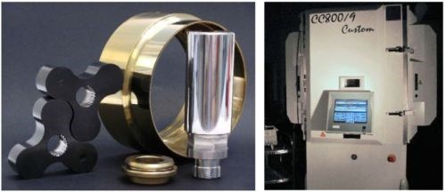

 -  To the left are seen different machine components PVD-coated with diamond-like carbon, TiN and CrN.  To the right is seen a special customized HiPIMS (High Power Impulse Magnetron) PVD unit from CemeCon AG customized for the Danish Technological Institute.